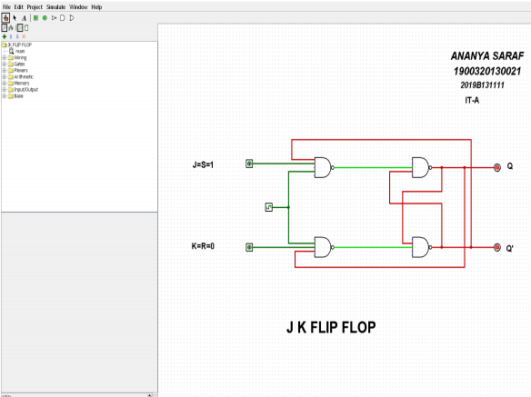

Ayush Jain  
1900320130050  
IT A